OWNER′S MANUAL

GASOLINE CHAIN SAW

YD-KU01-41
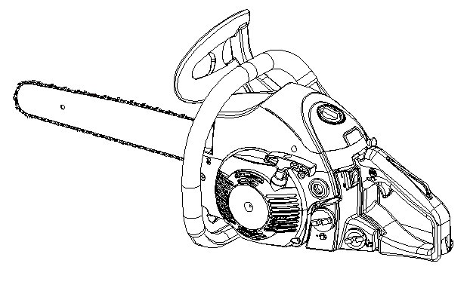

EXPLANATION OF SYMBOLS AND SAFETY WARNINGS



Read operator’s instruction
book before operating this Wear head, eye and ear
machine. protection.

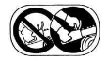

Use the chain saw Warning! Danger of
with two hands. kickback.


Read, understand and
follow all warnings.

Contents
1.For Safe Operation ……………………………………………… 3
2.Explanation of Symbols on the Machine ………………………………5
3.Installing Guide BarandSaw Chain …………………………………… 6
4.Fuel and Chain Oil ……………………………………………………… 7
5.Operating the Engine …………………………………………………… 8
6.Sawing ……………………………………………………………………10
7.Maintenance …………………………………………………………… 11
8.Maintenance of Saw Chain and Guide Bar……………………………12
9.Troubleshooting Guide …………………………………………………13
10.Specifications……………………………………………………………14

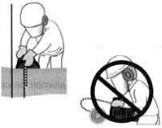
1. For safe operation


- Never operate a saw when you are fatigued, ill, or upset, or under the influence of medication that may make you drowsy, or if you are under the influence of alcohol or drugs.


- Use safety footwear, snug fitting clothing and eye, hearing and head protection devices.

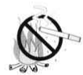
- Always use caution when hand- ling fuel. Wipe up all spills and then move the chain saw at least 3m from the fueling point before starting the engine.
3a. Eliminate all sources of sparks or flame(i.e. smoking, open flames, or work that can cause sparks)in the areas where fuel is mixed, poured, or stored.
3b. Do not smoke while handling fuel or while operating the chain saw.

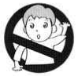
- Do not allow other persons to be near the chain saw when starting or cutting. Keep bystanders sho- uld be a minimum of 10m away when you start of operate the chain saw.
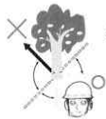

- Never start cutting until you have a clear work area, secure footing, and a planned retreat path from the falling tree.

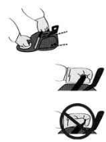
- Always hold the chain saw firmly with both hands when the engine is running. Use a firm grip with thumb and fingers encircling the chain saw handles.

- Keep all parts of your body away from the saw chain when the engine is running.

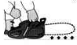
- Before you start the engine, make sure the saw chain is not contacting anything.

- Always carry the chain saw with the engine stopped, the guide bar and saw chain to the rear, and the muffler away from your body.
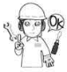
- Always inspect the chain saw be- fore each use for worn, loose, of damaged parts. Never operate a chain saw that is damaged, im- properly adjusted, or is not com- pletely and securely assembled. Be sure that the saw chain stops moving when the throttle control trigger is released.

- All chain saw service, other than the items listed in the Owner’s Manual, should be performed by competent chain saw service personnel.(E.g., if improper tools are used to remove the flywheel, or if an improper tool is used to hold the flywheel in order to re- move the clutch ,structural dam- age to the flywheel in order to re- move the clutch, structural dam- age to the flywheel could occur which could subsequently cause the flywheel to disintegrate.)
- Always shut off the engine be- fore setting it down.
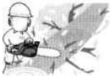
- Use extreme caution when cut- ting small size brush and sap- lings because slender material may catch the saw chain and be whipped toward you or pull you off balance.
- When cutting a limb that is un- der tension , be alert for spring back so that you will not be struck when the tension in the wood fibers is released.
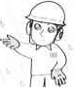

- Never cut in high wind, bad weather,when visibility is poor or in very high or low temperatures. Always check the tree for dead branches which could fall during the felling operation.

- Keep the handles dry, Clean and free of oil or fuel mixture.

- Operate the chain saw only in well ventilated areas. Never start or run the engine inside a closed room or building. Exh- aust fumes contain dangerous car- bon monoxide.
- Do not operate the chain saw in a tree unless specially trained to do so .
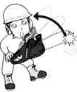
- Guard against kickback. Kick- back is the upward motion of the guide bar which occurs when the saw chain at the nose of the guide bar contacts an object . Kickback can lead to dangerous loss of control of the chain saw .

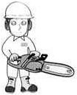
- When transporting your chain saw, make sure the appropriate guide bar scabbard is in place .

KICKBACK SAFETY PRECAU- TIONS FOR CHAIN SAW USERS

WARNING
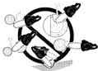
- Kickback may occur when the nose or tip of the guide bar touches an object, or when the wood closes in and pinches the saw chain in the cut . Tip contact in some cases may cause a lightning fast reverse reaction , kicking the guide bar up and back towards the operator. Pinching the saw chain along the top of the guide bar may push the guide bar rapidly back towards the operator. Enter of these rea- ction may cause you to lose control of the saw, Which could result in serious perso- nal injury.
- Do not rely exclusively on the safety devices built into your saw . As a chain saw user you should take several steps to keep cutting jobs free from accident or injury.
      - With a basic understanding of kickback you can reduce or eliminate the element of surp- rise. Sudden surprise contribu- tes to accidents.
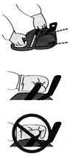
      - Keep a good grip on the saw with both hands on the rear handle, and the left hand on the front handle, when the engine is running . Use a firm grip with thumbs and fingers encircling the chain saw hand- les . A firm grip will help you reduce kickback and maintain control of the saw.

      - Make certain that the area in which you are cutting is free from obstructions. Do not let the nose of the guide bar contact a log, branch, or any other obstruction, which could be hit while you are operating the saw.
      - Cut at high engine speeds.

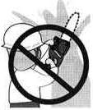
      - Do not overreach or cut above shoulder height.

      - Follow the manufacturer’s sha- rpening and maintenance inst- ructtions for the saw chain .

      - Only use replacement bars and chains specified by the manufacturer of the equivalent

2. Explanation of Symbols on the Machine

For safe operation and maintenance, symbols are carved in relief on the machine.
According to these indications, please be careful not to make any mistakd


The port to refuel ”MIX GASOLNE”
Position: Fuel cap

The port to top up chain oil
Position: Oil cap

Setting the switch to the “O” position, the engine stops immediately.
Position: Rear-left of the unit

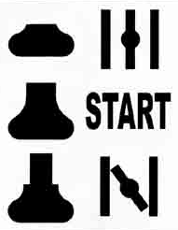
Starting the engine. If you pull out the choke knob (at the back-right of
the rear handle) to the point of the arrow, you can set the starting mode
as follows:
- First-stage position-starting mode when the engine is warm.
- Second-stage position-starting mode when the engine is cold.
Position: Upper-right of the air cleaner cover

The screw under the “H” stamp is The High-speed adjustment screw.
The screw under the “L” stamp is The Slow-speed adjustment screw.
The screw at the left of the “T” stamp is the ldle adjustment screw.
Position: Left side of the rear handle

Shows the directions that the chain brake is released (white arrow) and
Activated (black arrow).
Position: Front of the chain cover

3. Installing Guide Bar and saw Chain

A stand saw unit package contains the items as illustrated.

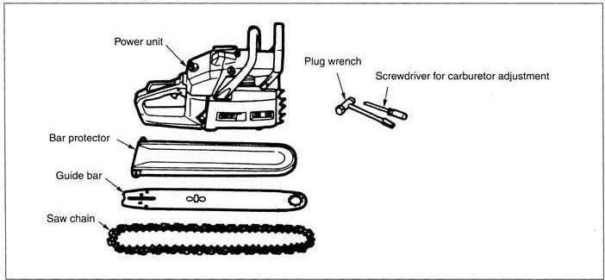
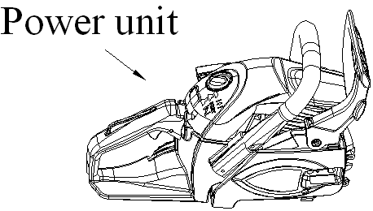

Open the box and install the guide bar and the saw chain on the power unit as follows:
The saw chain haw very sharp edges. Use thick protective gloves for safety.

- Pull the guard towards the front handle to check that the chain brake is not engaged.
- Loosen the nuts and remove the chain cover.
- Gear the chain to the sprocket and , while fitting the saw chain around the guide bar, mount the guide bar to power unit . Adjust the position of the chain tensioner.

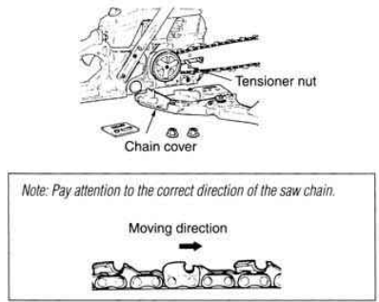

- t the chain cover to the power unit and fasten the nuts to finger tightness.
- While holding up the tip of the bar, adjust the chain tension by turning the tensioner screw unril the tie straps just touch the bottom side of the bar rail.
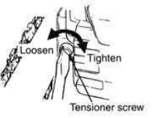

- Tighten the must securely with the bar tip held up (12~15N.m). Then check the chain for smooth rotation and proper tension while moving it by hand . If necessary, readjust with the chain cover loose.
- Tighten the tensioner screw.
Note: A new chain will expand is length in the beginning of use. Check and readjust the tension frequently as a loose chain can easily derail or cause rapid wear of itseif and the guide bar.

4. Fuel and Chain Oil

FUEL
WARNING

  - Gasoline is very flammable. Avoid smoking or bringing any flame or sparks near fuel. Make sure to stop the engine and allow it cool before refueling the unit. Select outdoor bare ground for fueling and move at least 3 m (10 ft) away from the fueling point before starting the engine.

  - Use an anti-oxidant added quality oil expressly labeled tor air-cooled 2-cycle engine use (JASO FC GRADE OIL or ISO EGC GRADE).

  - Do not use BIA or TCW(2-stroke water-cooling type)mixed oil.

RECOMMENDED MIXING RATIO
GASOLINE 35 : OIL 1
  - Exhaust emission are controlled by the fund- amental engine parameters and components (eq ., carburetion, ignition timing and port timing) without addition of any major hard- ware or the introduction of an inert material during combustion.
  - These engines are certified to operate on unread gasoline.
  - Make sure to use gasoline with a minimum octane number of 89RON(USA/Canada:87AL).
  - If you use a gasoline of a lower octane value than prescribed. There is a danger that the engine temperature may rise and an engine problem such as piston seizing may cones- quaintly occur.
  - Unleaded gasoline is recommended to reduce the contamination of the air for the sake of your health and the environment .
  - Poor quality gasoline s or oils may damage sealing rings, fuel lines or fuel tank of the engine.

HOW TO MIX FUEL
Pay attention to agitation
- Measure out the quantities of gasoline and oil to be mixed .
- Put some of the gasoline into a clean, app roved fuel container.
- Pour in all of the oil and agitate well.
- Pour in the rest of gasoline and agitate again for at least one minute. As some oils may be difficult to agitate depending on oil ingredients , sufficient agitation is necessary for the engine to last long. Be careful that, if the agitation is insufficient, there is an increased danger of early piston seizing due to abnormally lean mixture.
- Put a clear indication on the outside of the container to avoid mixing up with gasoline or other containers.
- Indicate the contents on outside of container for easy identification.

FUELING THE UNIT
- Untwist and remove the fuel cap. Rest the cap on a dustless place.
- Put fuel into the fuel tank to 80% of the full capacity.
- Fasten the fuel cap securely and wipe up any fuel spillage around the unit.
WARNING
- Select bare ground for fueling.
- Move at least 10 feet (3 meters ) away from the fueling point before starting the engine.,
- Stop the engine before refueling the unit. At that time, be sure to sufficiently agitate the mixed gasoline in the container.

FOR YOUR ENGINE LIFE,AVOID:
- FUEL WITH NO OIL( RAW GASOLINE)-It will cause severe damage to the internal engine parts very quickly.
- GASOHOL-It can cause deterioration of rubber and/or plastic parts and disruption of engine lubrication.
- Oil FOR4-CYCLE ENGINE USE-It can cause spark plug fouling, exhaust port blocking, or piston ring sticking.
- Mixed fuels which have been left unused for a period of one month or more may clog the carburetor and result in the engine failing to operate properly.
- In the case of storing the product for a long period of time, clean the fuel tank after rendering it empty. Next , activate the engine and empty the carburetor of the composite fuel.
- In the case of scrapping the use mixed oil container, scrap it only at an authorized repository site.
Note: As for details of quality assurance, read the description in the section Limited Warranty carefully. Moreover, normal wear and change in product with no functional influence are not covered by the warranty. Also,be careful that, if the usage in the instruction manual is not observed as to the mixed gasoline , etc . described therein, it may not be covered by the warranty.

CHAIN OIL
Use motor oil SAE #10W-30 all year round or SAE #30~#40 in summer and SAE #20 in winter
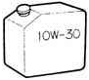

Note: Do not use wasted or regenerated oil that can cause damage to the oil pump.

5. Operating the Engine

- STATTING THE ENGINE
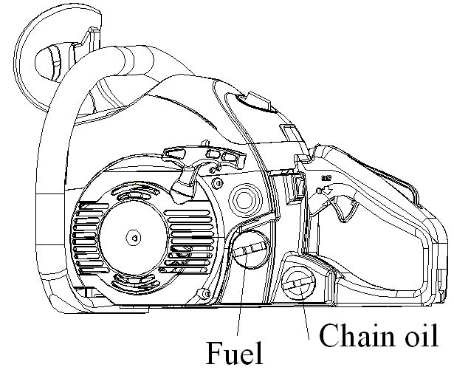
- Fill fuel and chain oil tanks respectively, and tighten the caps securely.
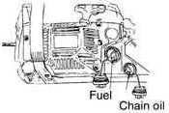

- Set the switch to “I” position.
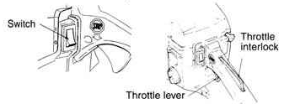

- Pull out the choke knob to the second-stage position. The choke will close and the throttle lever will then be set in the starting position.
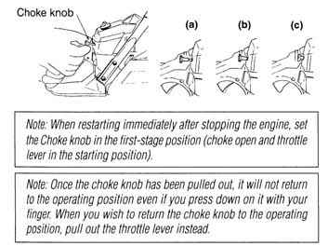

- While holding the saw unit securely on the ground, pull the starter rope vigorously.
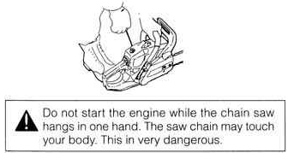

- When engine has ignited, first push in the choke knob to the first-stage position and then pull the starter again to start the engine.
- Allow the engine to warm up with the throttle lever pulled slightly.

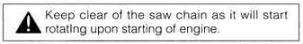

- CHECKING THE OIL SUPPLY
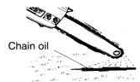
After starting the engine,run the chain at medium speed and see if chain oil is scattered off as shown in the figure.

- ADJUSTING THE CARBURETOR
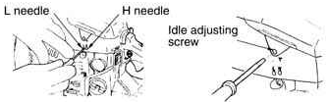

The carburetor on your unit has been factory adjusted, but may require fine tuning due to a change in operating conditions.
Before adjusting the carburetor, make sure that the provided air/fuel filters are clean and fresh and the fuel properly mixed.

When adjusting, take the following steps:

- Stop engine and screw in both the H and L needles until they stop. Never force them. Then set them back the initial number of turn as shown below.
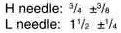

- Start the engine and allow it to warm up at half-throttle.
- Turn the L needle slowly clockwise to find a position where idling speed is maximum, then set the needle back a quarter (1/4) turn counterclockwise.
- Turn the idle adjusting screw (T) countercl- ockwise so that the saw chain does not turn. If the idling speed is too slow, turn the screw clockwise.
- Make a test cut and adjust the H needle for best cutting power, not for maximum speed.

- CHAIN BRAKE
This machine is equipped with and automatic brake to stop saw chain rotation upon occur- ence of kickback during saw cutting. The brake is automatically operated by inertial force, which acts on the weight fitted inside the front guard.
This brake can also be operated manually with the front guard turned down to the guide bar.
To release the brake , pull up the front guard toward the front handle till a “click” sound is heard.

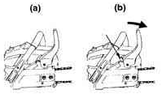

[Caution]

Be sure confirm brake operation during daily inspection.

How to confirm:
- Turn off the engine.
- Holding the chain saw horizontally, release your hand from the front handle , hit the tip of guide bar to a stump or a piece of wood, and confirm brake operation. Operating level varies by bar size.
In case the brake is not effective, ask our dealer for inspection and repairs.
If the engine keeps rotating at high speed with the brake engaged, the clutch will overheat causing trouble.
When the brake engages during operation, immediately release the throttle lever to stop the engine.

- STOPPING THE ENGINE
- Release the throttle lever to allow the engine to idle for a few minutes.
- Set the switch to the “O” (STOP) position.

Carburetor anti-freeze mechanism
Operating chain saws in temperatures of 0-5℃ at times of high humidity may result in ice forming within the carburetor, and this in turn may cause the output power of the engine to be reduced or for the engine to fail to operate smoothly.
This product has accordingly been designed with a ventilation hatch on the right side of the surface of the cylinder cover to allow warm air to be supplied to the engine and to thereby prevent icing from occurring.
Under normal operating mode, i.e., in the mode to which it is set at the time of shipment. However when the possibility exists that icing may occur, the unit should be setup operate the anti-freeze mode before use.

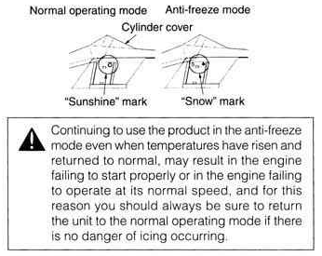

- HOW TO SWITCH BETWEEN OPERATING MODES
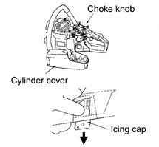

- Flip the engine switch to turn off the engine.
- Remove the cover to the air filter, remove the air filter, and then remove the choke knob from the cylinder cover.
- Loosen the screws holding the cylinder cover in place( i.e., the three screws on the inside and the one screw on the outside of the cover) , and then remove the cylinder cover.
- Press with your finger down on the icing cap located on the right-hand side of the cylinder cover to remove the icing cap.
- Adjust the icing cap so that the “snow” mark faces upwards and then return it to its original position in the cylinder cover.
- Fix the cylinder cover back into its original position, and then fix all other parts back into their proper positions.

6. Sawing

- Before proceeding to your job, read the section “For Safe Operation”. It is recommend- ed to first practice sawing easy logs. This also helps you get accustomed to your unit .
- Always follow the safety regu- lations. The chain saw must only be used for cutting wood. It is forbidden to cut other types of material. vibrations and kick- back vary with different mate- rials and the requirements of the safety regulations would not be respected. Do not use the chain saw as a lever for lifting, moving or splitting ob- jects. Do not lock it lever fixed stands. It is forbidden to hitch tools or applications to the PTO other than those specified by the manufacturer.

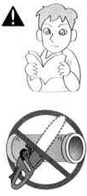

- It is not necessary to force the saw into the cut. Apply only light pressure while running the engine at full throttle.
- When the saw chain is caught in the cut, do not attempt to pull it out by force, but use a wedge or a lever to open the way.

- GUARD AGAINST KICKBACK
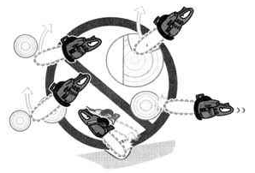

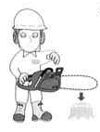
  - This saw is equipped with a chain brake that will stop the chain in the event of kickback if operating properly. You must check the chain brake operation before each usage by running the saw at full the throttle for I-2 seconds and pushing the front hand guard forward. The chain should stop immediately with the engine at full speed. If the chain is slow to stop or does not stop, replace the brake band and clutch drum before use.
  - It is extremely important that the chain brake be checked for proper operation before each use and that the chain be sharp in order to maintain the kickback safety level of this saw. Removal of the safety devices, inadequate maintenance, or incorrect repla- cement of the bar or chain may increase the risk ot serious per- sonal injury due to kickback.

- FELLING A TREE
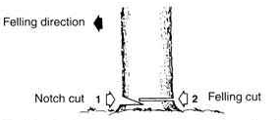

    - Decide the felling direction considering the wind, lean of the tree, location of heavy branches , ease of completing the task after felling and other factors.
    - While clearing the area around the tree, arrange a good foothold and retreat path.
    - Make a notch cut one-third of the way into the tree on the felling side.
    - Make a felling cut from the opposite side of the notch and at a level slightly higher than the bottom of the notch.
When you fell a tree, be sure to warn neighboring worker of the danger.

Bucking and Limbing
- Always ensure your foothold. Do not stand on the log.
- Be alert to the rolling over of a cut log. Especially when working on a slope, stand on the uphill side of the log.
- Follow the instructions in“ For Safe Operation” to avoid kickback of the saw.

Before starting work , check the direction of bending force inside the log to be cut. Always finish cutting from the opposite side of the bending direction to prevent the guide bar from being caught in the cut.

A log lying on the ground
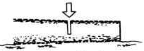

Saw down halfway , then roll the log over and cut from the opposite side.

A log hanging off the ground
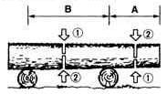

In area A, saw up from the bottom one- third and finish by sawing down from the top. In area B, saw down from the top one-third and finish by sawing up from the bottom.

Cutting the limbs of Fallen Tree
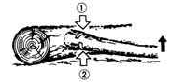

7.Maintenance
Before cleaning, the inspecting or repairing the unit, make sure that engine haw stopped and is cool. Disconnect the spark plug to prevent accidental starting.

- MAINTENANCE AFTER EACH USE
  - Air filter
Dust on the cleaner surface can be removed by tapping a corner of the cleaner against a hard surface. To clean dirt in the meshes, split the cleaner into halves and brush in gasoline. When using compressed air, blow from the inside.
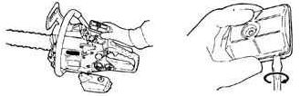

To assemble the cleaner halves, press the rim until it clicks.
  - Oiling port
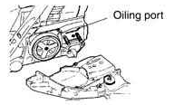
Dismount the guide bar and check the oiling port for clogging.

First check to which side the limb is bent. Then make the initial cut from the bent side and finish by sawing from the opposite side.
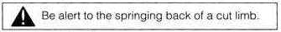

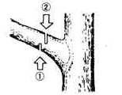
Pruning of standing Tree

Cut up from the bottom, finish down from the top.
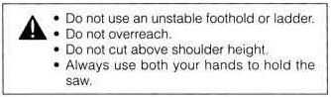

  - Guide bar
When the guide bar is dismounted, remove sawdust in the bar groove and the oiling port.
Grease the nose sprocket from the feeding port on the tip of the bar.
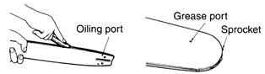

  - Others
Check for fuel leakage and loose fastenings and damage to major parts, especially handle joints and guide bar mounting. If any defects are found, make sure to have them repaired before operating the saw again.

- PERILDICAL SERVICE POINTS
  - Cylinder fins
Dust clogging between the cylinder fins will cause overheating of the engine. Periodically check and clean the cylinder fins after removing the air cleaner and the cylinder cover. When installing the cylinder cover, make sure that swit- ch wires and grommets are positions correctly in place.
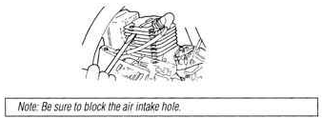

  - Fuel filter
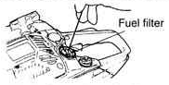
  - Using a wire hook, take out the filter from the filler port.

  - Disassemble the filter and with gasoline, or replace with a new one if needed.
Note:
·After removing the filter,use a pinch to hold
the end of the suction pipe.
·When assembling the filter,take care not to
allow filters or dust inside the suction pipe.
  - Oil tank
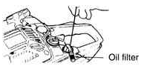
With a wire hook, take out the oil filter through the filler port and clean in gasoline. When putting the filter back into the tank, make sure that it comes to the front right corner. Also clean off dirt in the tank.

  - Spark plug
Clean the electrodes with a wire brush and reset the gap to 0.65 mm as necessary.
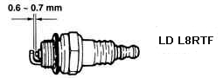

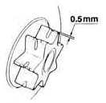
  - Sprocket

Check for cracks and for excessive wear interfering with the chain drive. If the wear is considerable, replace it with new one. Never fit a new chain on a worn sprocket, or a worn chain on a new sprocket.

8. Maintenance of Saw Chain and Guide Bar

- Saw Chain
It is very important for smooth and safe operation to always keep the cutters sharp.

The cutters need to be sharpened when:
- Sawdust becomes powder-like.
- You need extra force to saw in.
- The cut path does not go straight.
- Vibration increases.
- Fuel consumption increases.

Place the file on the cutter and push straight for ward.
Keep the file position as illustrated.
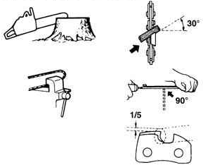

Cutter setting standards:
Be sure to wear safety gloves.

Before filling:
- Make sure the saw chain is held secu- rely.
- Make sure the engine is stopped.
- Use a round file of proper size for the chain .
Chain type: (1)Oregon 91VG (2)Carlton N1C
File size: 5/32 in(4.0 mm)

After each cutter has been filed, check the depth gauge and file it to the proper level as illustrated.
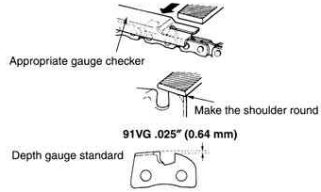

Be sure to round off the front edge to
reduce the chance of kickback or tie-
strap breakage.

Make sure every cutter has the same length and edge angles as illustrated.
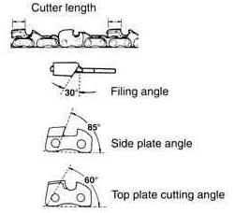

- Guide Bar
- Reverse the bar occasionally to prevent partial wear.
- The bar rail should always be square. Check for wear of the bar rail. Apply a ruler to the bar and the outside of a cutter. If a gap is observed between them, the rail is normal. Otherwise, the bar rail is worn. Such a bar needs to be corrected or replaced.

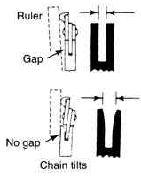

9. Troubleshooting Guide

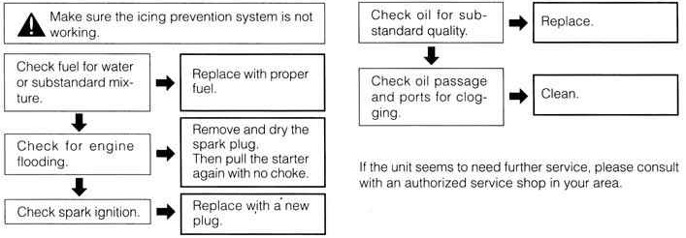
Case 1. Starting failure

Case 2. Lack of power/Poor acceleration/
Rough idling
Case 3. Oil does not come out

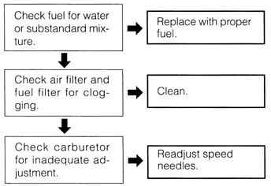

10. Specifications

Power unit:
Cutting head:

Displacement (cm³): ……………………..….. 40.1
Fuel :…..Mixture (Gasoline 35 :TWO-cycle oil 1 )
Fuel tank capacity (ml):………………………..400
Chain oil:………………...Motor oil SAE# 10W-30
Oil tank capacity (ml)…………………………..210
Carburetor: ……….Diaphragm type (Walbro WT)
Ignition system: ………………….Pointless (CDI)
Spark plug: ……………………NHSP LD L8RTF
Oil feeding system: …………….Automatic pump
Sprocket(Teeth Pitch) :………………….6T×3/8”
Dimensions(L×W×H)(mm):…..450×250×282
Guide bar
Type: ……………………….. .Sprocket nose
Size(in.(mm)):…14(355),16(405),18(455
Saw chain
Type: ………………………
（1）.Oregon 91VG
（2）Carlton N1C
Pitch (in.(mm)): …………………….3/8(9.53)
Gauge (in.(mm)):…………………0.05(1.27)

Specifications are subject to change without notice.

Power unit only (kg):………………………… 4.5
Dry weight
Peak power(w): ………………………… 1500w
Idling speed（r/min）…………………………3200
Max cutting speed（r/min）………………10000

